10bpc Feature Enabling In Win10 SDR Mode

Get Started Guide

December 2021

Intel Confidential

You may not use or facilitate the use of this document in connection with any infringement or other legal analysis concerning Intel products described herein. You agree to grant Intel a non-exclusive, royalty-free license to any patent claim thereafter drafted which includes subject matter disclosed herein.

No license (express or implied, by estoppel or otherwise) to any intellectual property rights is granted by this document.

All information provided here is subject to change without notice. Contact your Intel representative to obtain the latest Intel product specifications and roadmaps.

The products described may contain design defects or errors known as errata which may cause the product to deviate from published specifications. Current characterized errata are available on request.

Copies of documents which have an order number and are referenced in this document may be obtained by calling 1-800-548-4725 or visit [www.intel.com/design/literature.htm](http://www.intel.com/design/literature.htm).

Intel technologies' features and benefits depend on system configuration and may require enabled hardware, software or service activation. Performance varies depending on system configuration. No product or component can be absolutely secure. Check with your system manufacturer or retailer or learn more at [intel.com](http://intel.com/) or most relevant URL to your product.

Intel, the Intel logo, are trademarks of Intel Corporation or its subsidiaries in the U.S. and/or other countries.

*Other names and brands may be claimed as the property of others.

© Intel Corporation

Contents

1.0 Introduction 4

2.0 Driver and tools preparation 5

2.1 Download and install GPU driver and tools 5

3.0 Enable 10bpc (10-bit per color) on intel GPU. 6

3.1 HDMI 10bpc enabling 6

3.2 DP 10bpc enabling 7

4.0 10bpc (10-bit per color) feature validation 11

# Introduction

This document contains detailed instructions for enabling 10-bit per color (10bpc) feature in Win10 DP and HDMI SDR mode.

## Terminology

Table 1. Terminology

| Term | Description |
| --- | --- |
| HDMI | High Definition Multimedia Interface |
| DP | Display Port Interface |
| 10bpc | 10-bit Per color |
| TGL | Tiger Lake |
| GPU | Graphics Processing Unit |
| IGCC | Intel Graphics Command Center |

# Driver and tools preparation

This section describes the software environment setup.

## Download and install GPU driver and tools

* + Download and Install latest GPU driver from link

<https://www.intel.com/content/www/us/en/download/19344/intel-graphics-windows-dch-drivers.html>

* + Download and Install IGCC (Intel Graphics Command Center)

10bpc feature for HDMI interface should be enabled by IGCC. The download links as below: <https://www.intel.cn/content/www/cn/zh/products/docs/graphics/graphics-command-center.html>

* + Download DP Applet tool

10bpc feature for DP interface should be enabled by DP Applet tool. The download links as below: https://www.intel.com/content/www/us/en/secure/design/confidential/software-kits/kit-details.html?kitId=646371&s=Newest

# Enable 10bpc (10-bit per color) on intel GPU.

Currently, 10bit per color feature enabling on intel CPU have different methods for HDMI and DP

## HDMI 10bpc enabling

HDMI 10bpc feature is enabled by IGCC (Intel Graphics Command Center).

Open IGCC, then Select “BPC_10” in “Color Depth” dropdown in “Display” page.

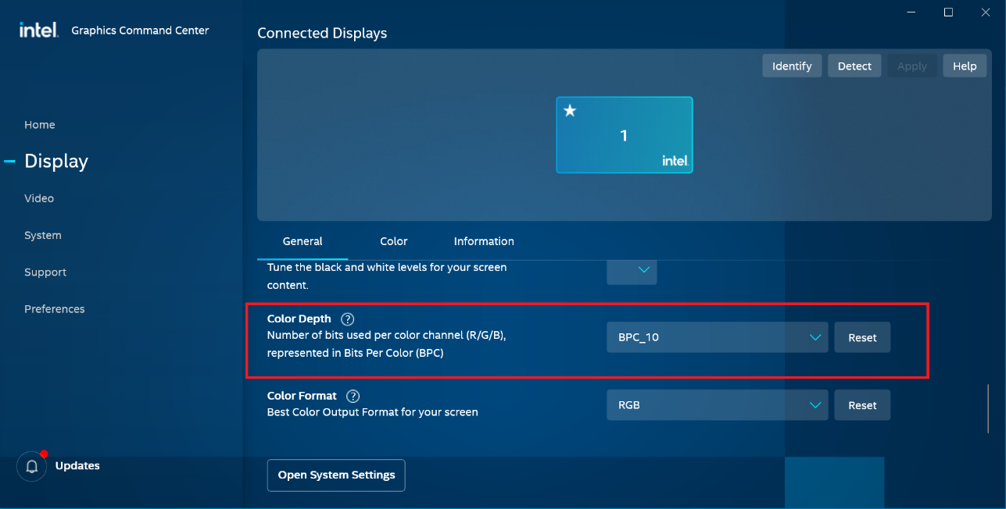

If setting correct, “Bit Depth” would be 10-bit in “Advance display settings” page as below

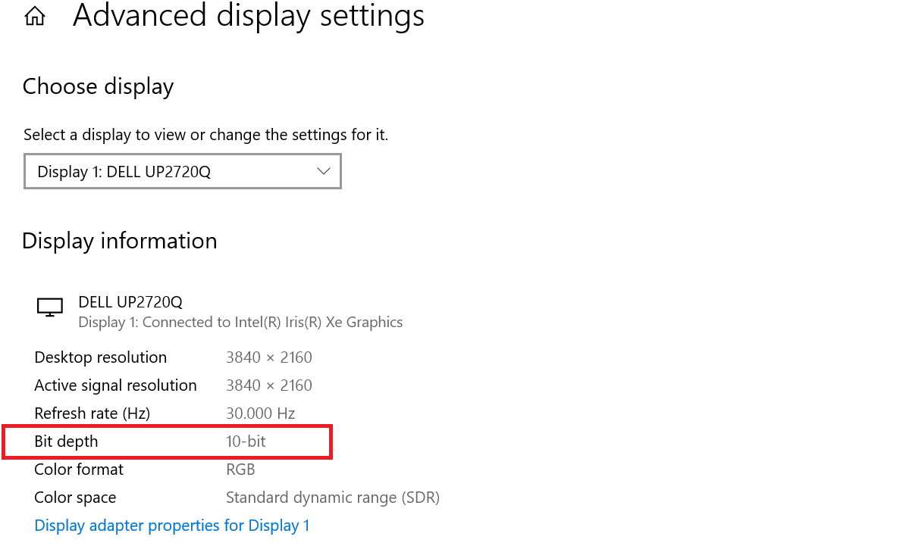

## DP 10bpc enabling

DP 10bpc feature is enabled by DP Applet as follow steps.

1. Choose the items which are marked as red, then click “Set BPC” button to set 10bpc for DP .

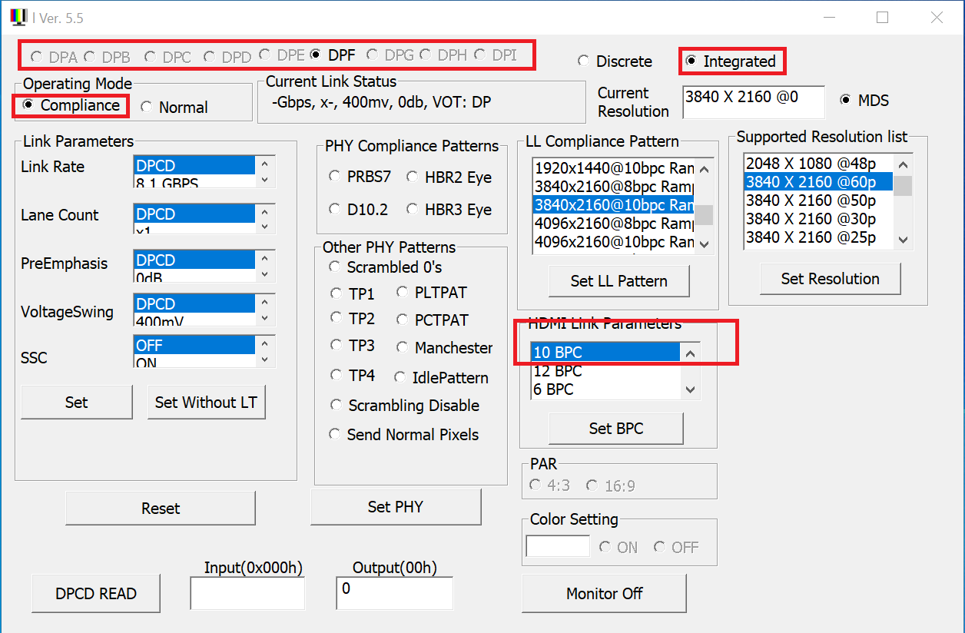

1. First click “Disable Device” button first, and then click “Enable Device” button to trig 10bpc configuration

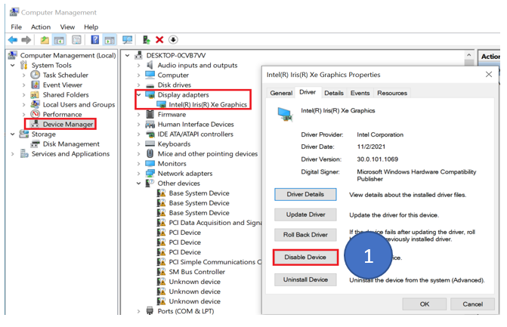

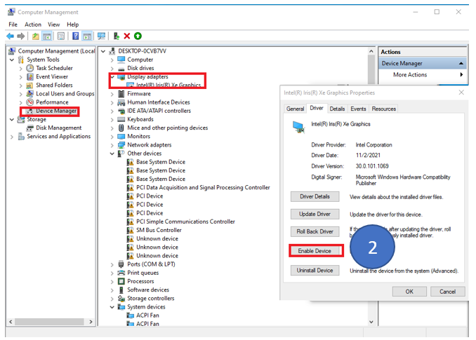

1. Due to Win10’s bug, 10bpc feature is not detected by Win10 in “Advance display settings” page in DP SDR mode. We can check 10bpc enabling status in registry editor. If setting correct, follow two keys are set in registry editor. Computer\HKEY_LOCAL_MACHINE\SYSTEM\CurrentControlSet\Control\Class\{4d36e968-e325-11ce-bfc1-08002be10318}\0000

SelectBPC = 0x01000000

SelectBPCFromRegistry = 0x0a000000

**Note: if many times setting don’t work, please try to modify the key “SelectBPC=0x01000000” and “SelectBPCFromRegistry = 0x0a000000” manually.**

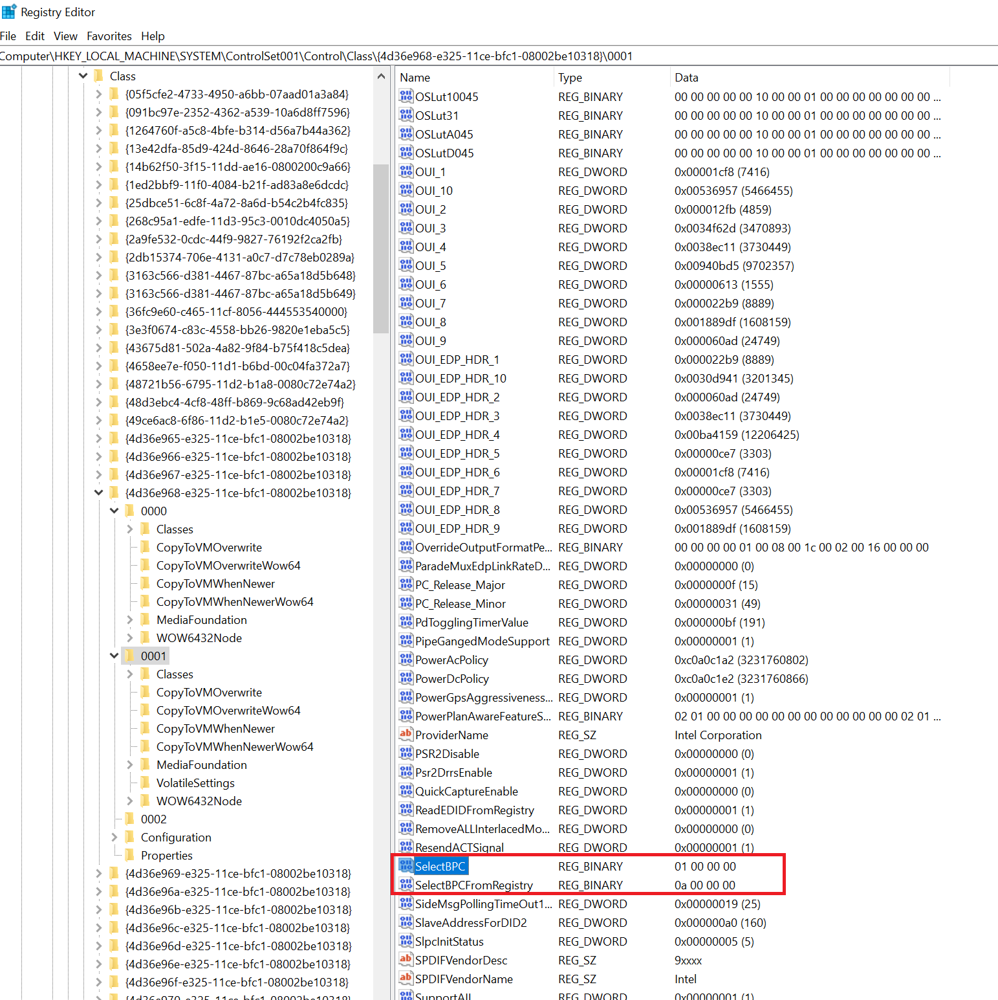

# 10bpc (10-bit per color) feature validation

The application 10bpc_demo is used to validate 10bpc effect on intel CPU.

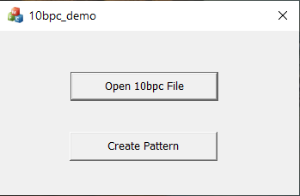

* 1. “Open 10bpc File” button

It loads and renders an image which includes 10bpc content, then 10bpc effect can be seen on the monitor which supports 10bpc.

You can get the image from <https://github.com/jursonovicst/gradient>.

* 1. “Create Pattern” button

It creates a grey scale image by HLSL. The image includes 8-bit and 10-bit content. Comparing the 8-bit and 10-bit content in the image, we can verify if the 10bpc effect is working.